**Special Paper for Computer Architecture**

1. Answer following questions (10 Marks)

i. Draw the truth table for following circuit.

ii. Derive the output of the following circuit and compare the output with truth table of following gates (AND, NAND, and XOR etc..)

Logic 1.tif

2. Draw the truth table for following logic circuit. Derive the possible output. (10 Marks)

Logic 2.tif

2. (25 Marks)

i. Convert following decimal numbers to the binary format. (Show the steps taken)

a. 70

b. 30

c. 50

ii. Do following operations using the binary values of each number.

a. 70 + 30

b. 70 – 30

c. 30 + 70 + 50

d. 50 + 30 – 70

iii. What is the result of adding following two numbers?

0 + 0 = …

0 + 1 = …

1 + 0 = …

1 + 1 = … and to ...

iv.

|  |  |  |  |
| --- | --- | --- | --- |
| **A** | **B** | **SUM** | **CARY** |
| 0 | 0 | … | … |
| 1 | 0 | … | … |
| 0 | 1 | … | … |
| 1 | 1 | … | … |

v. Represent the sum and the carry out put using two input logic gate in the following block diagram.

A

B

Cary

A

B

SUM

vi. Using above logic gates, design a Half Adder logic circuit.

A

B

SUM

CARY

vii. Using above Half Adder circuit design the full adder logic circuit in the following block diagram.

A

B

SUM

CARY

Cin

1. Main hardware component of the computer is shown in the figure shown in the bellow.

4. (Marks 15) 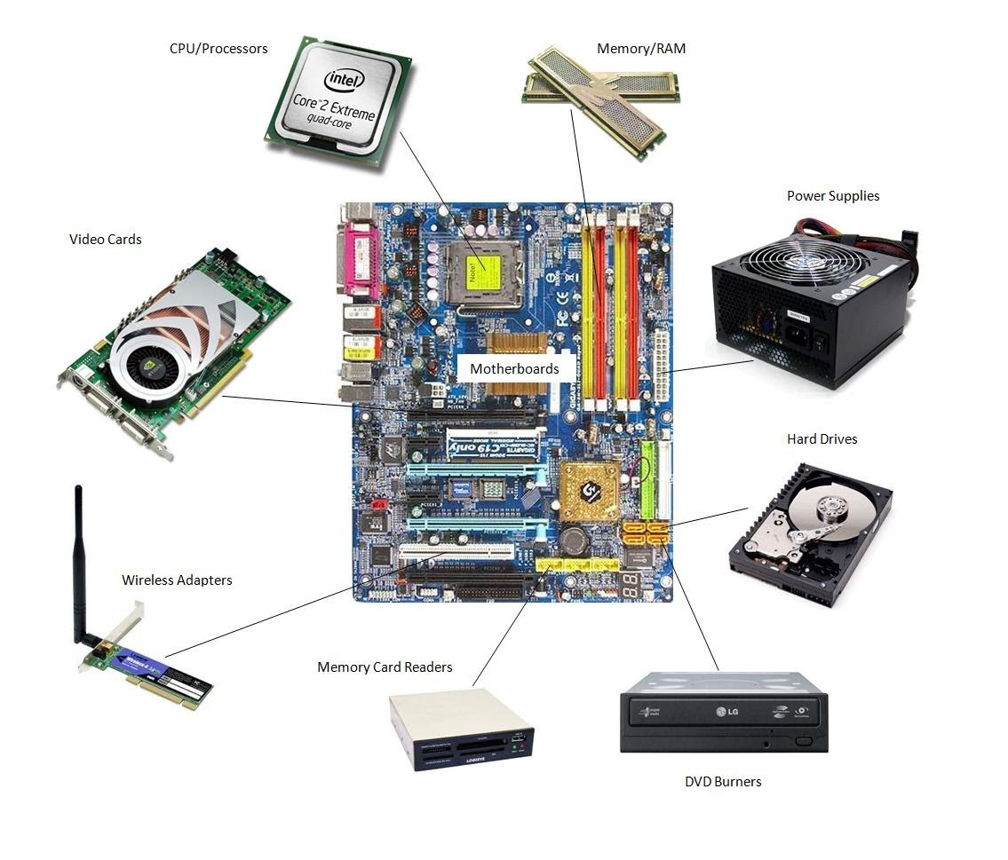

i. What is the main purpose of the Motherboard?

ii. Hard drive and the Memory are used to store the data. What are the main differences of Memory (RAM) and Hard Drive?

iii. Suddenly the computer losses the power due to power failure. What happened to the data in the RAM ?

iv. Mother board of my computer failed. Are my data in the hard disk safe ?

v. Why there is a FAN fitted on a CPU but no fans on hard disk or RAM.

5. a. Name the followings busses shown in the picture (Marks 10)

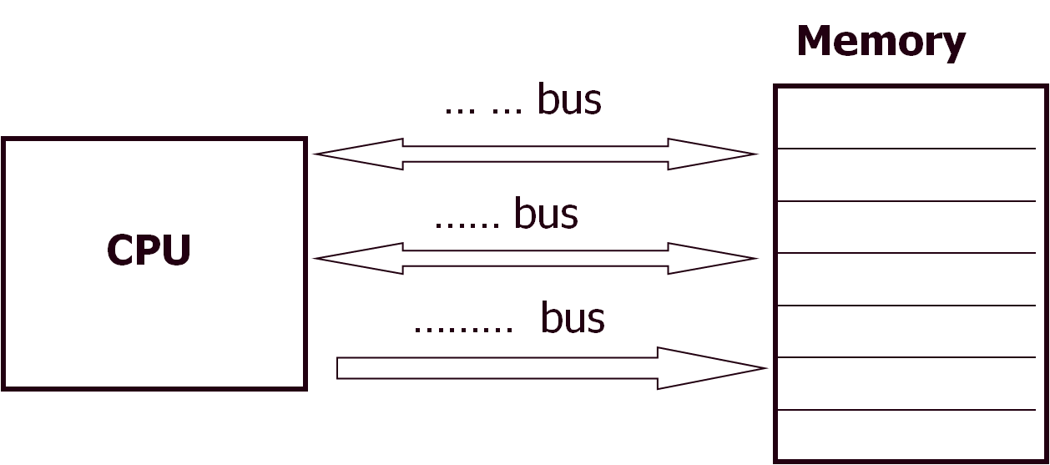

b. Explain the operation of each bus.

6. Prove the following shift operation perform the required operation using graphical aids. (15 Marks)

The **Arithmetic Shift** instruction performs multiplication or division.

|  |  |  |  |  |  |  |  |
| --- | --- | --- | --- | --- | --- | --- | --- |
| 0 | 1 | 0 | 1 | 1 | 0 | 1 | 0 |

Use 8 bit binary value in the 8 bit register.

i. Convert binary number to the decimal number

ii. Multiply the binary number by 2 using binary shift operator

Hence obtain the decimal value for binary output.

iii. Divide the value by 2 using the binary shift operator.

Hence obtain the decimal value for binary output.

7. Put the following memory and storage devices in to a pyramid with a hierarchical order. (Marks 15)

Hard Drive, Magnetic Tape, USB Drives and SD Cards, Processor Cash, Processor Registry, RAM.

Following featured to be consider

Cost, Size, Speed, Data Storage Capability with Power On/OFF Conditions